**Mastering Embedded System Diploma.**

[**www.learn-in-depth.com**](http://www.learn-in-depth.com)

**First term (Final Project 1).**

**Eng. : Anwar Ahmad Anwar Adly.**

**My Profile :** [**https://www.learn-in-depth.com/online-diploma/anwarahmadanwaradly%40gmail.com**](https://www.learn-in-depth.com/online-diploma/anwarahmadanwaradly%40gmail.com)

Contents

1. Case Study. 2

2. Method. 3

3. System Requirements. 4

4. HW/SW Partitioning & Design Space Exploration. 5

5. System Analysis. 6

Use Case Diagram. 6

Activity Diagram. 6

Sequence Diagram. 6

6. System Design. 7

State Machine Diagram. 7

Flowcharts. 7

Interactive Simulation. 8

7. Simulation. 9

Mapfile. 10

# Case Study.

**The client wants the software of the following system with this**

* **Specifications :**
* **Pressure controller informs the crew of cabin with an alarm when the pressure exceeds 20 bars in the cabin.**
* **The alarm duration equals 60 seconds.**
* **Assumptions :**
* **Microcontroller used is STM32F103xxx.**
* **Alarm will be buzzer and led indicator.**
* **The cabin must be closed to appropriate measuring**
* **Versioning :**
* **Version1 : the output will not save the value of pressure at each instance and all in the cabin can not know the instance pressure.**
* **Version2 : the output will save the pressure values in flash memory and can be traced.**
* **Version3 : the output will save the pressure values and showed it on console (LCD or Monitor in the cabin).**

# Method.

**We will use V-model to Software Development Life Cycle (SDLC)**

**and Software Testing Life Cycle (STLC)**

**Advantages of V-model :**

* **Straightforward and easy for the development of software.**
* **Helps to save a lot of time compared to the general process of implementation.**
* **Provides a proactive error tracking feature for developers.**
* **No problem with the downward data flow.**



# System Requirements.

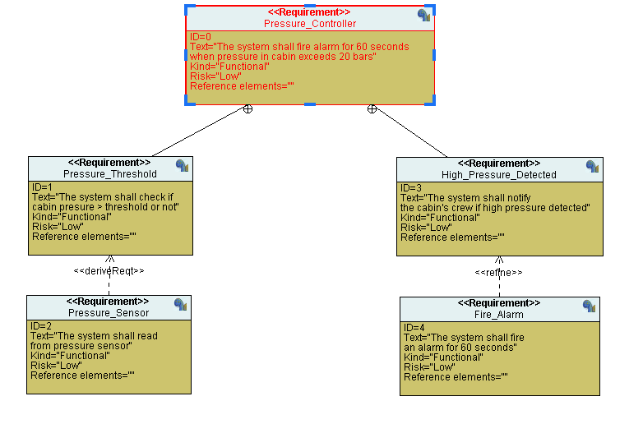

# HW/SW Partitioning & Design Space Exploration.

**Implements a specification on some sort of multiprocessor architecture to speed up the software and reduce energy.**

**It’s all about allocation and scheduling of the system and it’s response to different architecture.**

**Analysing various functions equivalent implementation alternatives**

**To affects in these parameters :**

* **Speed.**
* **Power consumption.**
* **Silicon area.**
* **Generation of heat.**
* **Development effort.**

# System Analysis.

## Use Case Diagram.

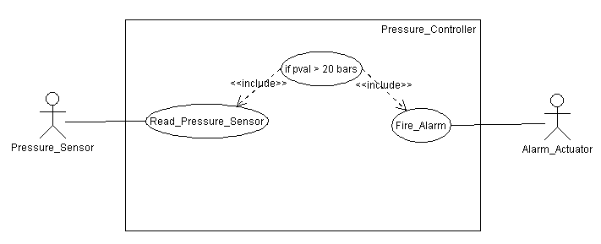

## Activity Diagram.

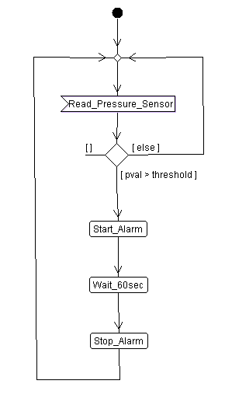

## Sequence Diagram.

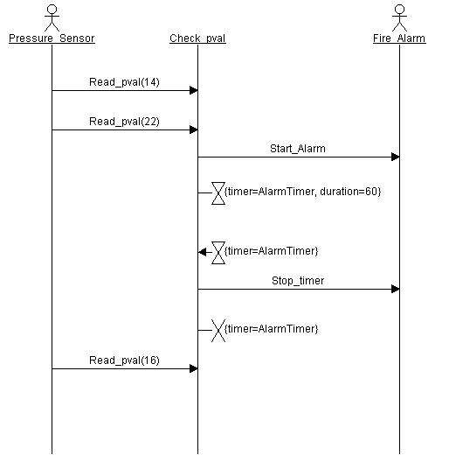

# System Design.

## State Machine Diagram.

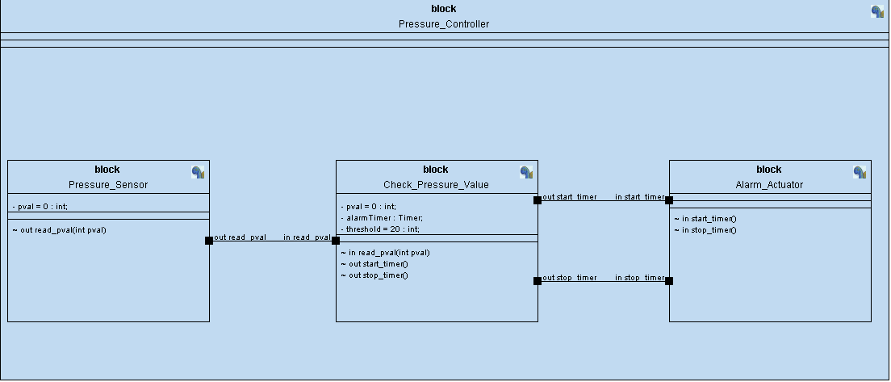

## Flowcharts.

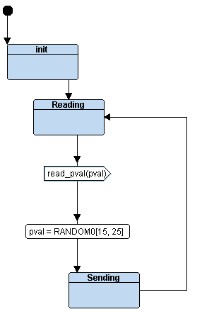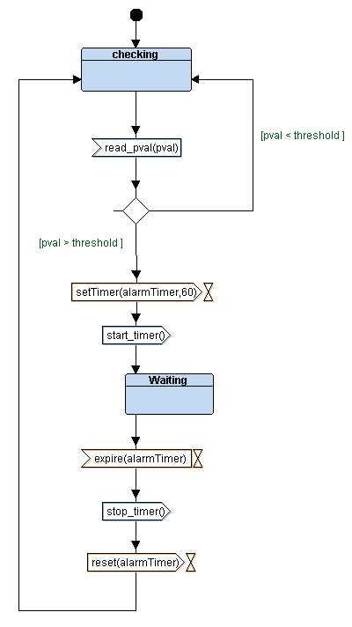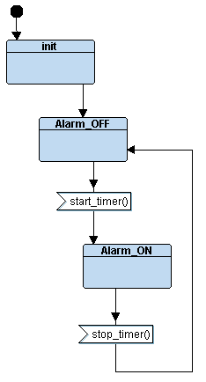

## Interactive Simulation.

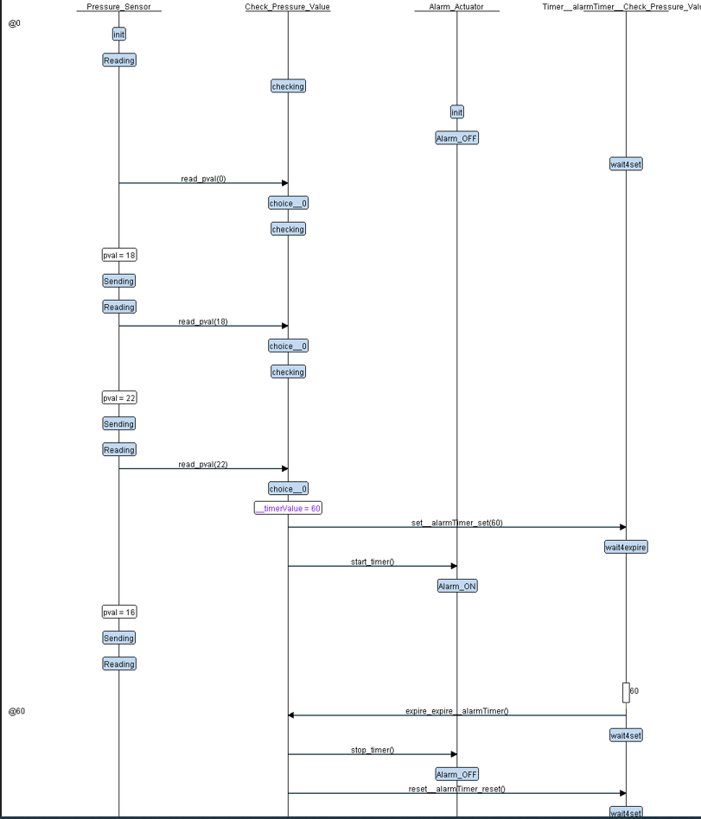

# Simulation.

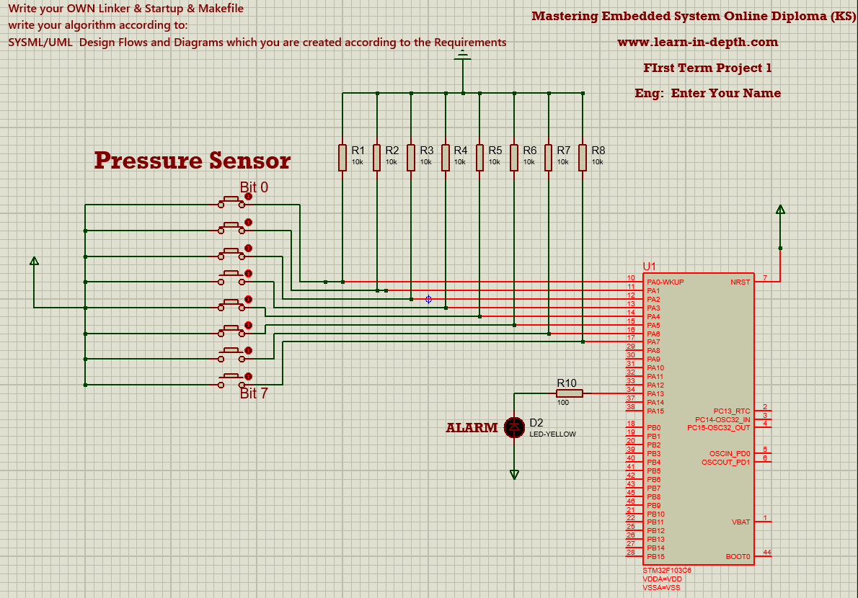

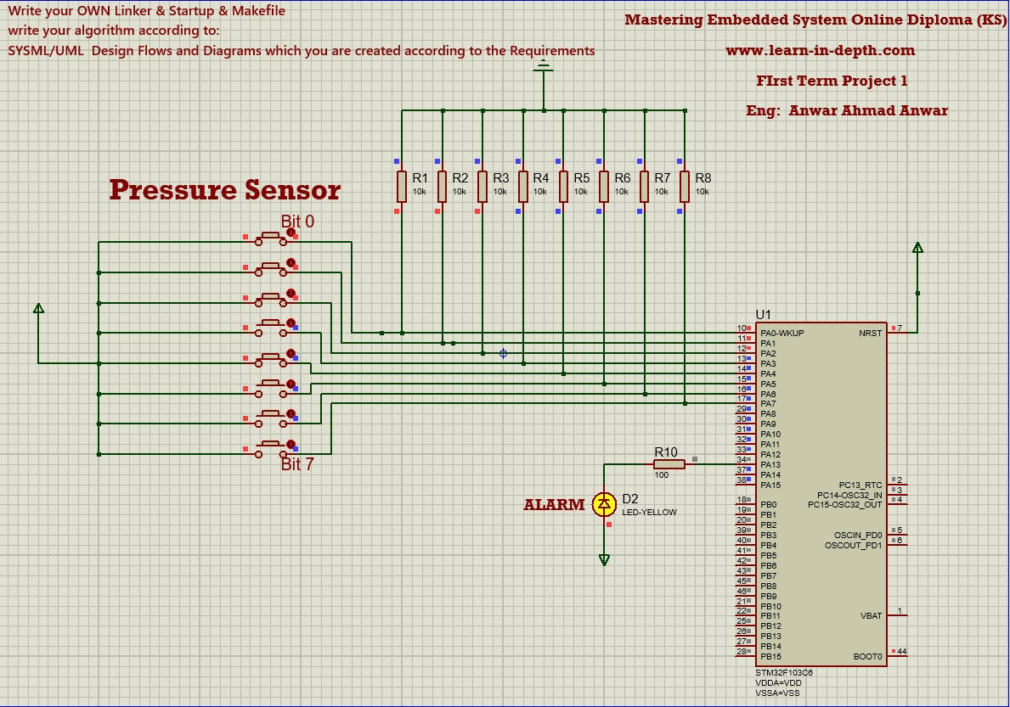

## Mapfile.

